Pocket Watch
A Fan-made Micro Version of Set a Watch

Credit to Todd Walsh and Mike Gnade, the designers of Set a Watch, as well as the publisher, Rock Manor Games. I also want to credit Andreas Rocha and Robert P. Schneider, who are listed as the artists on BGG. Wonderful game and wonderful art. I created Pocket Watch using the game’s original art with permission from the publisher. Pocket Watch is a free print and play game and should not be sold for profit.

This rules sheet will first go through the full rules set for Pocket Watch. If you haven’t played Set a Watch before, this is the place to start. Then I have a section with just the differences from the original game. That will be the fastest way to learn Pocket Watch for experienced players of Set a Watch.

Feel free to reach out to me through email or on Facebook with any question or feedback:

Joe Klipfel
joeklipfel@gmail.com

Table of Contents

1. Pocket Watch Full Rules (page 1)
2. Just the Differences from Set a Watch (page 10)

Full Rules for Pocket Watch

Card Breakdown
- 4 adventurer cards
- 1 camp card
- 1 location card
- 12 creature cards

You’ll Need
- 6 d8 dice
- 6 d6 dice
- 9 blue cubes (8 for blue character tracking and 1 for future location tracking)
- 9 red cubes (8 for red character tracking and 1 for Horde tracking)
- 2 yellow cubes (for tracking firewood and what round you’re on)
- 1 green cube (to track current location)

Game Summary (from Set a Watch rulebook)
The kingdom is in grave danger. Powerful enemies are conspiring to resurrect the vile and powerful Unhallowed that your party has just slain. Now you, the mighty adventurers of the land, must visit these summoning locations and defeat the hordes of creatures behind this evil plot. It falls to four mighty adventurers, each of whom has a unique set of skills, to band together once more to vanquish this evil before the Unhallowed consume the world in darkness.

Pocket Watch is a cooperative game for one to four players. You must secure nine locations to prevent the acolytes from breaking the seals holding back the evil Unhallowed. Each round your party will visit a new location and choose an adventurer to rest and take strategic camp actions. The rest of the party will assume watch and confront a line of creatures attempting to breach your camp. Using your dice to do battle and activate unique class abilities, your team will need to approach each round’s combat puzzle with both cunning and resolve. In an epic campaign to stay alive, defeat the arisen Unhallowed, and keep the campfire burning, you must use your wits and skill to fight for the light—or all will perish into darkness.

Game Setup
Camp Card
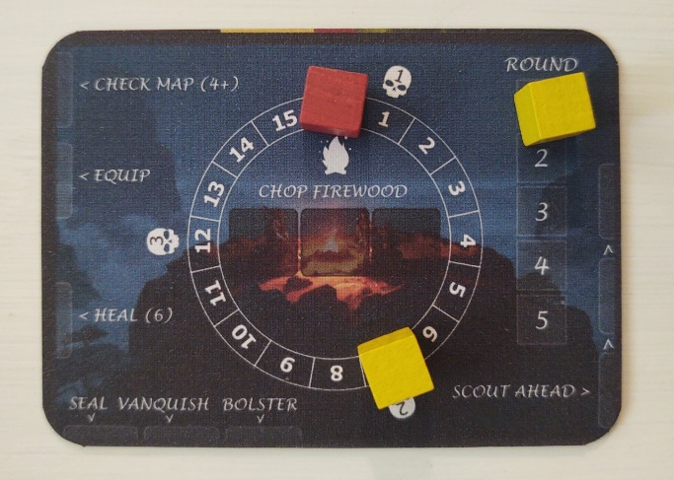
1. Set out camp card and components

Place the camp card within easy reach of all players. Place a yellow cube to indicate it is round 1 (you will play through 5 rounds total). Place another yellow cube on 7 on the circle in the middle to indicate starting firewood level. Finally, put a red cube on 0 on the same middle circle. This is how you will track how many creatures are in the horde. More on that later.

2. Set out the location card

Place the location card on the table somewhere still within reach. Set aside a green cube and a blue cube near the location card. During the game, you will use the green cube to track the current location, and the blue cube to track future locations, if a camp action has made this possible.
Location Card
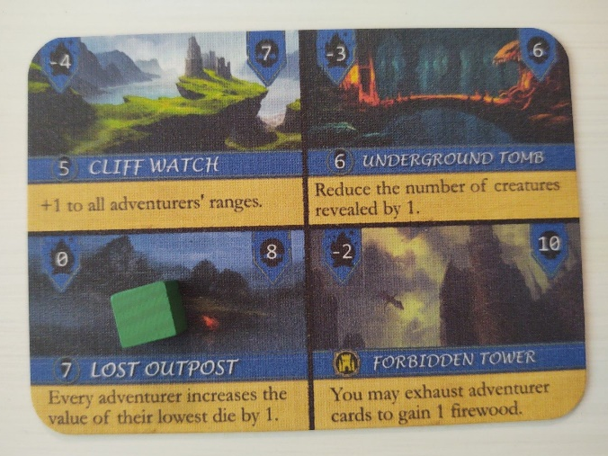
Select the first location of the game by rolling an eight-sided die (d8). Each location has a number left of the location name for this purpose. Place a green cube on the chosen location to remember where you are.

If you roll an 8, reroll until you get a valid location. An 8 would correspond to the final location, the Forbidden Tower. You will always fight at the final location in the final round (round 5), but you cannot go to the final location before the final round.

As the game goes on, you can choose to either replay locations if the die roll says to, or simply reroll until you get a location you have not yet been to.
Location Number
Number of Creatures in the Line
Effect on Firewood
3. Select four adventurers

Dice
Players select an adventurer and take 3 of the corresponding dice. An adventurer uses either six-sided (d6) or eight-sided (d8) dice. Red characters use d6’s and blue characters use d8’s. The Wizard, for example, uses six-sided dice as indicated by the icon at the upper right of his card and the red graphics on the card. During the game, place dice below the adventurer’s card after rolling for the round. When spent on direct attacks, place dice above the adventurer card.

Range
The adventurer’s range is either melee, indicated by a crossed swords icon at the upper right of the card, or ranged, indicated by a bow and arrow icon. Melee adventurers can only use direct attacks (dice attacks) on the first creature in line. Ranged adventurers can use direct attacks on creatures in the first or second position in line. Note that unlike direct attacks, abilities are not restricted by range.

Abilities
Adventurers start with 3 equipped abilities. Two of them start refreshed (usable right away) and one starts exhausted (cannot be used until refreshed). There are 5 abilities to choose from, but only 3 are equipped at a given time. You can choose your starting abilities randomly, or begin with the 3 abilities on the left half of the card for simplicity. Place cubes on the full/undamaged shield icon of the two refreshed abilities, and place a cube on the slashed shield icon of the exhausted ability. The remaining two abilities are not equipped and do not get cubes.

Special Camp Action
The upper right portion of an adventurer’s card has their special camp action. This is not the same as an ability. The special camp action can only be used when an adventurer is resting during a round instead of on watch. Each adventurer will rest only once during the game. Place a cube on the tent icon during setup. When the character has rested, move the cube to the other side of the special camp action section to track which adventurers have already rested.
An Adventurer Card

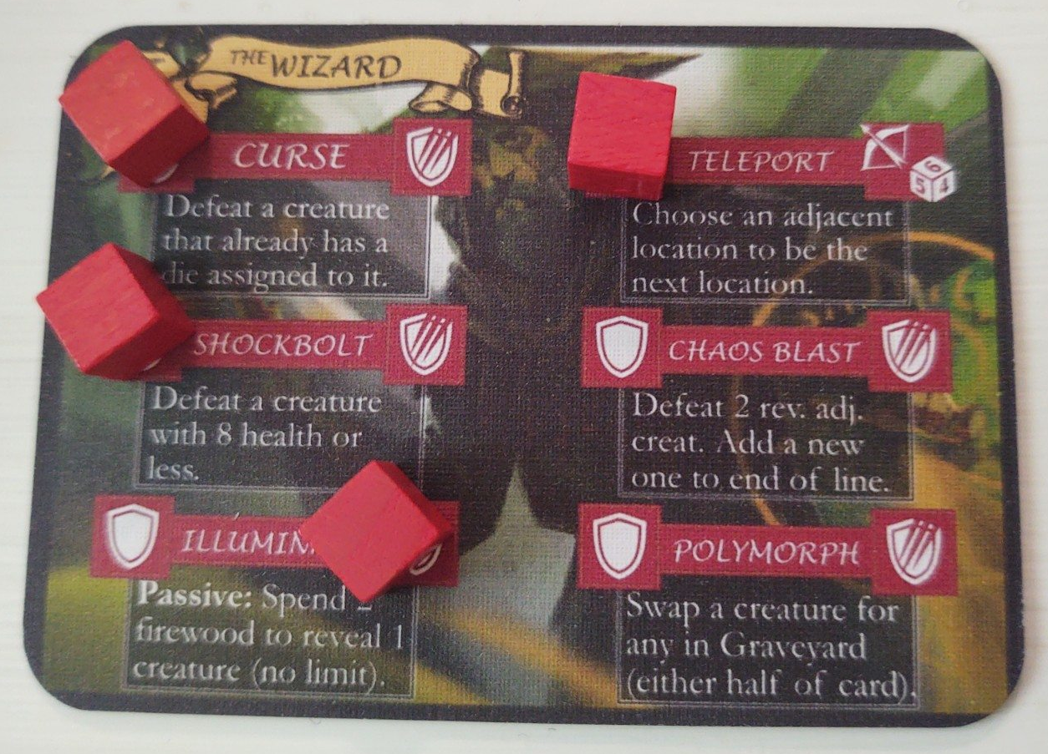
Unequipped abilities do not have cubes.
Wizard is a Ranged Character
Wizard uses Six-sided Dice
Adventurer’s special camp action.
Cube on full shield icon for refreshed abilities.
Cube on slashed shield icon for exhausted abilities.
NOTE: There must always be 4 adventurers in play no matter the player count. If you have 4 players, each selects one adventurer. With 3 players, pick a flex adventurer that the player in camp controls during the watch phase. In a 2 player game, each player selects two adventurers.

4. Prepare the creature deck.

There are 12 creature cards in the game. The creature deck is always made up of all 12 creature cards. Before the game and before every round, shuffle the creature deck. Rotate some cards 180 degrees when shuffling to ensure you’ll see a variety of creatures during the game. Set the creature deck within reach, near the location card and camp card.
Completed Setup

F.
E.
D.
C.
B.
A.
A. Creature deck. You will draw creature cards from this deck to set out the line at the beginning of each round. Some creature abilities or adventurer abilities will also instruct you to interact with the creature deck.

B. Graveyard/Horde. When you defeat creatures, place them face up in the graveyard. If you are unable to defeat a creature they are still placed in the graveyard, but you must take the appropriate damage and increase the horde by 1. Taking damage means you look at the creature’s damage value (shield icon at upper left of their card) and exhaust that many adventurer abilities. You choose which abilities to exhaust. Increasing the horde means you move the red cube on the camp card up 1 space to increase the size of the horde. The horde increases the length of the line in the final round.

C. Location card. Put a green cube on the current location. If the next location has been predetermined due to a camp action, put the blue cube on the next location. Note that half of the locations are on the back of the card. If the next location is on the reverse side of the card, place the blue cube just next to the card instead of on the card in the appropriate position to indicate the next location is on the reverse side in that quadrant of the card.

D. Camp card.

E. The creature line. First position is closest to the camp card (furthest left) and last position is furthest from the camp card (furthest right).

F. Adventurer cards.

Creature Cards

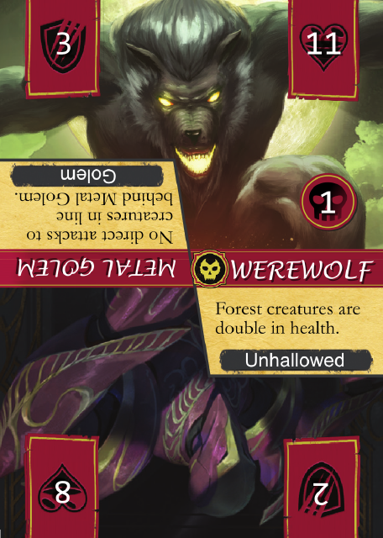
Creature cards show you the abilities, health, damage and type of each creature. When creatures are defeated they go to the graveyard. If they are not defeated, they are sent to the horde and you must take damage.
A.
B.

Creature cards each have two creatures on them. When you reveal creature cards, you only deal with the creature on the top half of the card and ignore the upside-down creature on the bottom half.
C.
A. Damage. This is how many abilities from the adventuring party are exhausted if the creature cannot be defeated. This is not per player; it is the total number of cards exhausted among the players on watch. You choose collectively which adventurer(s) will take the damage. The resting adventurer cannot take damage.
D.
E.

B. Health. The number that must be met or exceeded with dice to destroy a creature. Note that creatures can be manipulated and even defeated by adventurer abilities in addition to direct attacks from dice.

C. Power text. Unique effects that occur when triggered. Power text effects are typically ongoing. Sometimes a power text will say “reveal” or “first position”. Reveal means as soon as the card is flipped over, the effect happens—but just one time. First position means the effect only happens if the creature reaches first position.

D. Creature type. This tells you what kind of creature you are dealing with. Adventurer abilities sometimes apply only to certain creature types. Unhallowed are considered to be creatures with creature type Unhallowed.

E. Skull number. Only Unhallowed have skull numbers. See more on Unhallowed in the next section.

Unhallowed
Unhallowed are the big baddies you are trying to avoid running into. There are 7 Unhallowed in the game, and as you can see in the creature card image above, Unhallowed share cards with normal creatures. You can tell which creatures are Unhallowed because 1) they have a skull number, 2) they have the Unhallowed symbol next to their name, and 3) their creature type is Unhallowed.

You activate (rotate so they are on top) Unhallowed when their skull number matches the round you are on.

EXAMPLE: It is round one and you reveal the first creature in line. It is the above card with Metal Golem on one half and Werewolf on the other. Metal Golem had actually been on top when you revealed the card, but you see that Werewolf’s skull number is 1. Since it is round 1 of the game, you activate Werewolf, rotating so he is on top and you must deal with him. If it had been any other round, you would have ignored the Werewolf and dealt with Metal Golem instead.

IMPORTANT: When an Unhallowed activates, you must immediately exhaust an adventurer ability of your choice. The exception is when the Unhallowed is activated due to the Acolyte’s power text. In that case you do not need to exhaust an adventurer ability. Only Unhallowed that activate due to their skull number matching the current round force you to exhaust an ability.

Gameplay
At the beginning of the game and before every round, roll a die to determine the next location as described above in the location card section. Next, players roll their dice and then decide which adventurer goes to camp to use their dice for camp actions. The rest of the party members stay on watch. Players on watch are tasked with eliminating creatures that will threaten the party. These creatures are referred to as the line. The adventurer in camp assigns his or her dice to any camp actions and completes those actions.

Camp Phase
The adventurer in camp does not participate in combat. Instead this player places his or her rolled dice on any available placements on/beside the camp card. Each adventurer also has a special camp action in the upper right section of their adventurer card that can be used as a camp action, with a die being assigned to it just like other camp actions. The adventurer in camp refreshes one of his or her exhausted cards for free immediately when he or she enters camp.

The resting adventurer completes all their camp actions before the adventurers on watch begin battling the creature line.

Camp Actions

Chop Wood (max of 3 placements): Increase firewood by 2 for every die placed in the chop wood location.

Scout Ahead (max of 3 placements): Draw and look at the top 2 creatures in the creature deck. Rearrange them however you like and return each card to either the bottom or top of the creature deck. Each additional die placement requires a die greater than the one just placed.

Check Map (max of 1 placement): Roll a d8 twice (or until you get 2 unvisited locations). Choose one of the two options to be the location next round. Place a blue cube on the chosen location to remember. If the chosen location is on the opposite side of the location card, place the blue cube in that area but beside the card. Check Map action requires a die of 4 or greater. You cannot swap out the final location.

Heal (max of 1 placement): Refresh 1 exhausted ability for yourself or any adventurer on watch. Requires a die of exactly 6.

Equip (max of 1 placement): Exchange one of your currently-equipped abilities for one that is not equipped. If the ability you exchanged was exhausted, the new ability you equipped must also be exhausted.

Adventurer Special Camp Actions

Each adventurer has their own special camp action. These are listed on the upper right of the adventurer cards. You spend a die to activate these abilities like any other camp action. Each adventurer camp action can only be used once per round, and only when they are resting in camp that round.

Rune Camp Actions

Three of the camp actions are called rune actions. The rune actions are special because they require either doubles or three-of-a-kind to activate. The rune actions are seal, vanquish and bolster. The dice are placed next to the rune you wish to activate. You must select at least two rune actions and cannot select the same rune action twice. Triples allow you to activate all three.

Seal (max 1 placement): If an Unhallowed activates during the round for any reason, you may swap it for an Unhallowed in the graveyard. The Unhallowed you grab from the graveyard can be from either half of the card (top or bottom). You can do this action multiple times during the round if more than one Unhallowed activates. If there are no creatures in the graveyard you cannot do the seal action.

Vanquish (max 1 placement): Reduce the horde by 1. This means simply moving the red horde tracking cube on the camp card to reduce the size of the horde.

Bolster (max 1 placement): All adventurers on watch may choose to reroll any number of their dice.

Each adventurer MUST rest at camp once during the game. Once an adventurer has rested, move the cube on the special rest action section on their card over to the right side, revealing the tent icon and reminding you which adventurers have rested. In the final round, all adventurers go on watch.

When all of the resting adventurer’s dice are assigned and camp actions completed, continue to the watch phase.

Watch Phase
Set up the Line
Look at your current location to see how many creatures you will face in the line this round. Without looking, deal cards from the creature deck and place them face down in a line, starting with the top card closest to the camp card. Stop adding cards to the line when the number of cards in the line equals the creature count noted on your current location. If you ever need to draw a card from the creature deck and cannot, shuffle the graveyard to create a new creature deck.

Reveal Monsters
Check the current firewood value to see how many creatures are revealed by the campfire light (if at firewood level 7, two creatures are revealed and if at firewood level 12, three creatures are revealed, etc.). Reveal creatures closest to the camp card first and resolve their abilities one at a time. Once a creature is revealed, it stays revealed even if the firewood value decreases enough to affect the number revealed. Players then use their dice and abilities to send creatures to the graveyard. When all creatures in the line have been defeated, players draw a new location and begin a new round.

Combat Actions

Direct Attacks
Adventurers on watch will use their dice and abilities to defeat the creatures in the line and send them to the graveyard. Players may assign and combine their dice for direct attacks to revealed creatures. When combined die values meet or exceed the creature’s health, it is defeated and sent to the graveyard. Once dice have been used to defeat a creature in a direct attack, they are spent and cannot be used again this round. Place them above the adventurer card to remember they are spent.

Abilities
Alternatively, players can place a die on an unexhausted ability to activate it. This can only be done once per ability per round. If you choose, you can activate an ability by exhausting it instead of placing a die on it (when you exhaust an ability, move the cube from the left side of the ability over to the right side). You can do this even after a die has already been spent on the ability to activate it once. In other words, if you choose you can assign a die to an ability to activate the ability—and in the same round you can exhaust that ability to activate the ability a second time that round. Remember, you cannot activate the ability more than once per round with just assigning dice to it. The only way to use an ability twice in a round is to first assign a die to it and then exhaust it.

Passive abilities do not need dice assigned to them or need to be exhausted to activate. They are the exception. They are typically ongoing effects that can be used whenever relevant. Some passive abilities say “max 1 per round” or have a “(1)” in the ability text. This means using the ability is still free, but you can only use it once per round.

Turn Order & Taking Damage
Players can activate and assign dice in whatever order they see fit (there is no turn order) until all creatures have been defeated or all adventurers run out of useful actions. A player cannot participate in combat if all their abilities are exhausted at the start of the watch phase. If adventurers run out of actions and there are still creatures in the line, add that creature card to the graveyard and increase the horde by 1. You must also exhaust a number of adventurer abilities equal to the damage value of the creature you didn’t defeat. Whenever abilities need to be exhausted, you must exhaust cards from the adventurers on watch, not the resting adventurer.

Locations & Ending the Round

Once the line is clear and if the adventurers on watch are not all exhausted, the round was completed successfully. A game will consist of 5 rounds and a different location for each round. The final round will always take place in the final location (the Forbidden Tower). When a round is completed, roll a d8 to determine the next location. Reroll until you get a location you have not been to yet. Locations determine how much firewood is removed or added to the campfire (see location card section above). The location also tells you how many creatures will be placed in the line and any unique effects the location will have. Clearing a location requires all creatures in the line be either defeated or sent to the horde with appropriate damage taken.

Final Round

Round 5 is the final round. The final location follows some different rules from the other rounds.

First, all four adventurers go on watch. No one rests.

Second, you can, if you choose, exhaust an ability to increase firewood by 2. This can be done at any time during the round.

Third, you must deal with the horde in the final round. Creatures are drawn and placed normally in the line. Then, look at horde tracker on the camp card to see how many extra creatures you have to deal with this round. Add that many extra creature cards to the end of the line.

There are 12 creature cards in the game, and there is a chance the horde might require your creature line to have more cards in it than 12. If this happens, deal out all 12 creature cards into the line, and reduce the horde tracker by the number of extra cards you were able to add. Then as creatures are defeated at the front of the line, flip them back over, rotate them randomly so you don’t know which half is on top, place them at the back of line face down, and reduce the horde tracker by 1. Do this until the horde has reached zero and then proceed with taking on the creature line as normal.

During the round, you can send creatures to the horde as necessary (taking appropriate damage), but this does not lengthen the creature line. You don’t have to deal with the new horde that may be created in the final round.

Even if you did not defeat all creatures in the final round, as long as you have 1 unexhausted ability remaining on any single adventurer after taking creature damage, you have won the game.

End Game

You win the game by making it through all 5 rounds successfully. If the party’s firewood ever reaches zero, you must immediately exhaust an ability card to increase the firewood by 2. If all adventurers on watch become exhausted by the end of a round, the party has fallen and the game is lost.
Alternative Difficulty Settings

Casual: Adventurers start with all three equipped abilities refreshed.

Normal: Normal rules as stated in the rulebook.

Hard: “Dual Unhallowed” rules. Unhallowed activate if their skull number matches the current round and/or if their skull number matches the previous round. E.g., in round 5 you’ll be facing the Unhallowed with skull number 5 as well as those with skull number 4.

Impossible: “Stacking Unhallowed” rules. Unhallowed activate if their skull number matches the current round and/or any previous round. E.g., by round 5 you’ll be facing literally all the Unhallowed that show up.

Just the Differences from Set a Watch

The gameplay is the same as Set a Watch except for the differences below.

Creature Deck
The creature deck is made up of 12 cards. Each card has 2 creatures on it. Before you deal out the line at the beginning of a round, shuffle up the 12 creature cards and deal out the line as normal based on what the location tells you. Set the remaining cards aside—this is the creature deck. When you reveal creatures, flip the card over and the creature on top of the card is the creature you are dealing with. Ignore the upside-down one on the bottom half of the card. When you shuffle the creature deck, make sure to rotate some of the cards 180 degrees to ensure variety.

Before you deal out the creature line for the next round, shuffle up the entire creature deck again, including the Graveyard and the Horde, and deal out the line as normal. You essentially start from scratch on the Graveyard every round, shuffling it back into the creature deck.

Horde
Start a new Graveyard each round. If you need to send a creature to the Horde, put it in the Graveyard. Use the firewood tracker in the center of the camp card to track the Horde in addition to firewood level. I use a yellow cube for the firewood level and a red cube for the Horde. Start with the red cube on 0 and increase it by 1 every time you send a creature to the Horde.

In the final round, just extend the line by the number of creatures in the Horde. If you don’t have enough creatures in the deck to do this, use the Horde tracking cube to note how many creatures are left in the Horde, and as you defeat creatures in the line, add them face down to the end of the line and reduce the Horde tracker by 1.

For example, say I’m setting up the final location. It calls for 9 creatures in the line. I have 5 creatures in the Horde according to my Horde tracking cube. There are only 12 creature cards in the game, and I need a line of 14. Uh oh! Don’t worry, there’s a solution. I set out my line using all 12 creatures and reduce my Horde tracker down from 5 to 2 (because 3 of the Horde have already been added to the line). When I defeat the first creature in line, instead of sending it to the Graveyard, I add it to the end of the line face down and reduce my Horde tracker by 1. Once I have no more creatures left in the Horde, I start adding defeated creatures to the Graveyard instead of putting them back at the end of the line.

Rounds
There are only 5 rounds in Pocket Watch. Each adventurer gets to rest only once, and must rest only once. All adventurers are on watch in the final location, like in the original game. Track what round you are on using a yellow cube and the Round tracker (1-5) on the campsite card.

Unhallowed
This is the single biggest difference from the original game. If you can get this, you are pretty much good to go. Unhallowed activate based on what round of the game you are on instead of from summon cards. There are no summon cards in Pocket Watch.

There are 7 Unhallowed in Pocket Watch. All Unhallowed share a card with a normal creature. I added a Skull number to the Unhallowed cards. It’s the number straight south of the Unhallowed’s health. It’s in a circle and has a skull icon behind it.

When you reveal a creature and it has an Unhallowed on one half of the card, rotate the card so that the normal creature is on top and is the one you deal with, and the Unhallowed is on bottom and ignored. Do this unless the Skull number of the Unhallowed matches the round you are on. In that case, rotate the card so the Unhallowed is on top for you to deal with.

For example, say I am on round 1 of the game. I reveal the first creature. It has the Lich (an Unhallowed) on one half and a Fell Beast (a normal creature) on the other. The Lich had actually been the creature on top when I revealed it, but since the Lich has a Skull number of 4, I ignore him (because I’m on round 1) and rotate the card so the Fell Beast is on top. If I run into the Lich in round 4, I’ll have to deal with him then. I reveal the next creature card and it has the Werewolf (an Unhallowed) on one half and the Metal Golem (a normal creature) on the other. Since I’m on round 1 and the Werewolf’s Skull number is 1, I rotate the card so the Werewolf is on top. I deal with his card text and everything as normal, just like when an Unhallowed is summoned in the original game.

Locations
There is a single location card with 4 locations on each side. Location number 8 is the final location. You can come up with your own favorite system for randomly choosing the next location. What I like to do is roll a d8. If I get an 8 (the final location) or a location I’ve already been at, I reroll until I get a new one. It wouldn’t be an issue if you want to live at the whim of the die and replay a location if it says to. Place the green cube on the current location to remember where you are.

Player Boards
Instead of abilities being represented by cards, they will be tracked with cubes on your adventurer card. Each equipped ability gets a cube on it that corresponds with the character’s color (red or blue). Place the cube on the filled-in shield icon on the left side of the ability to indicate it is refreshed. If an ability is exhausted, place the cube on the slashed shield icon on the right side of the ability. You can randomly select starting abilities if you want, but I tried to put the 3 least desirable abilities along the left side so I can start with those and equip one of the other two abilities as the game goes on. That way I feel like I’m leveling up.

The upper right section of the adventurer card has their special camp action. At the start of the game, place a cube on the tent icon on the left side of the camp action. Once an adventurer has camped/rested, move that cube to the right side to remember they have rested. Each adventurer only rests once in Pocket Watch since there are only 5 rounds. The icons on the right side of the camp action indicate whether the adventurer is melee or ranged, as well as if they roll d6’s or d8’s.

Camp Actions
I had to adjust a few camp actions to make it work for the micro game, but it works. For most camp actions you place your die just off the card in the designated position. I stack dice if I need to when chopping firewood.

Seal - When an Unhallowed activates this round, you can (if you choose) swap out that Unhallowed with another from the Graveyard. You can do every time you run into an Unhallowed this round. The Unhallowed you pull from the graveyard can come from either half of the card.

Vanquish - Reduce the Horde tracker by 1.

Check Map - Roll a d8 twice. You get to choose which location you want to go to next out of these two. Place a blue cube so you remember which location you’ve chosen.

Adventurer Abilities
A handful of adventurer abilities wouldn’t work in the Pocket Watch model so there are a few adjustments below. If there is a “(1)” in the ability text, it means you can only use it once per round.

Beastmaster
- At the end of the round he has to give up his tamed creatures. Yes, you can tame a creature that would have had an Unhallowed that triggered on the other half of the card.

Wizard
- Wizard’s Teleport camp action lets you choose an adjacent location to be the location next round. In other words, if you are on location 4, you can choose either location 3 or location 5 to be your next location. If at location 7, you choose between location 6 and location 1.
- When using Polymorph, you can choose either half of the card you pull from the Graveyard.

Rogue
- For Stay Dead, creatures you defeat without help from others have to sit out from the game the next round. The round after that, put them back in the creature deck. Yes, you can do this for creatures that have an Unhallowed on the other half that you would have faced next round.

Acolyte
If Acolyte reaches first position, you activate any revealed Unhallowed. This means if there are Unhallowed out there on the bottom half of the card that were not active because it was not their round—all these are rotated to the top half of the card and must be dealt with. This only occurs once per round, and happens only fi Acolyte reaches first position.

